

**Department of Computer Science and Engineering**

**21st Batch**

**Lab Report 1**

|  |  |
| --- | --- |
| Course title | : Computer Graphics Lab |
| Course Code | : CSE - 422 |

|  |  |  |  |
| --- | --- | --- | --- |
| **Submitted By** | | **Submitted To** | |
|  |  |  |  |
| Name | : Md. Mahfujur Rahman | Name | : Ayesha Akter Lima |
| ID | : 192311014 | Designation | : Lecturer,  Varendra University,  Rajshahi |
| Section | : A |  |
| Semester | : 11th |  |
| Batch | : 21st | Name | : Monika Kabir |
|  |  | Designation | : Lecturer  Varendra University,  Rajshahi |
|  |  |  |

------------

|  |  |
| --- | --- |
| Signature | Submission date: |
|  |  |

**Problem Statement:** Installation and Introduction to “**OpenGL**” and print 15 random points of different colors.

**Installation:**

1. 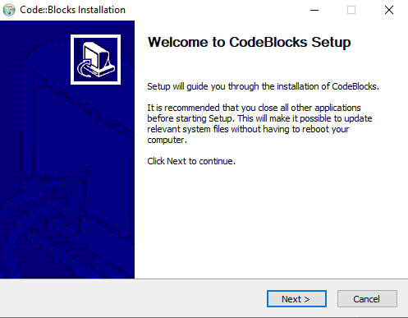Install ‘CodeBlocks’ with “MinGW”.
2. Download freeglut 3.0.0

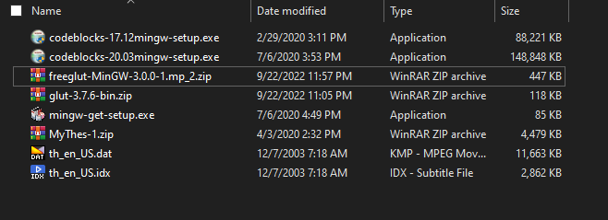

1. Extract

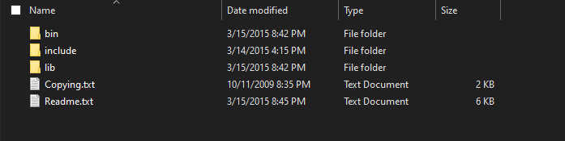

1. Go to the <CodeBlocks> and then share > CodeBlocks Templates

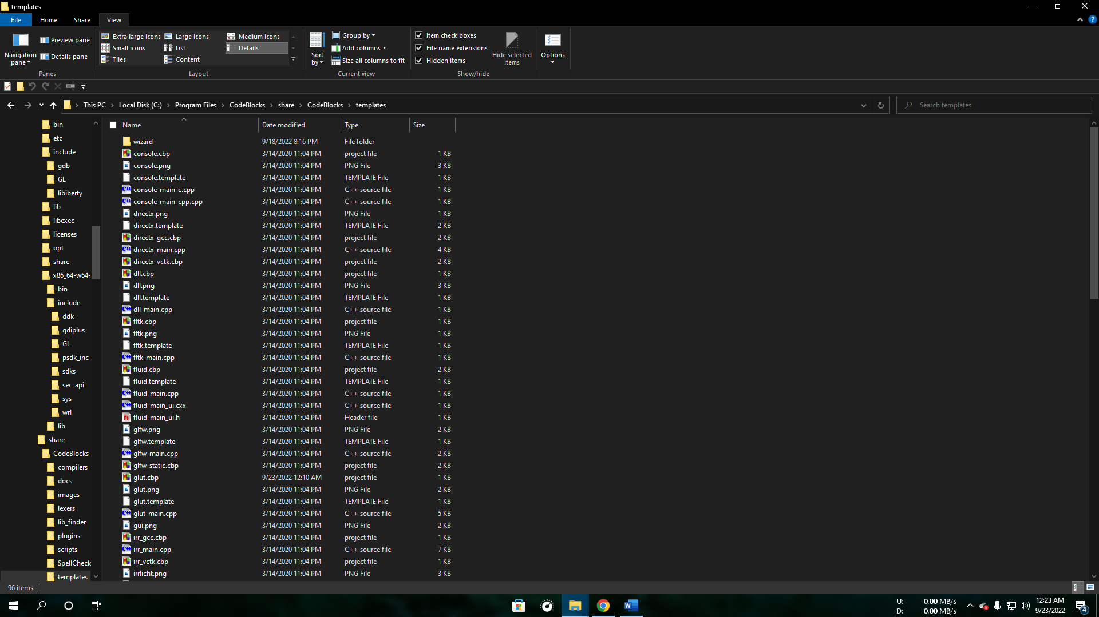

1. Now open “glut.cbp” with Notepad and replace all ‘glut32’ with ‘freeglut’.

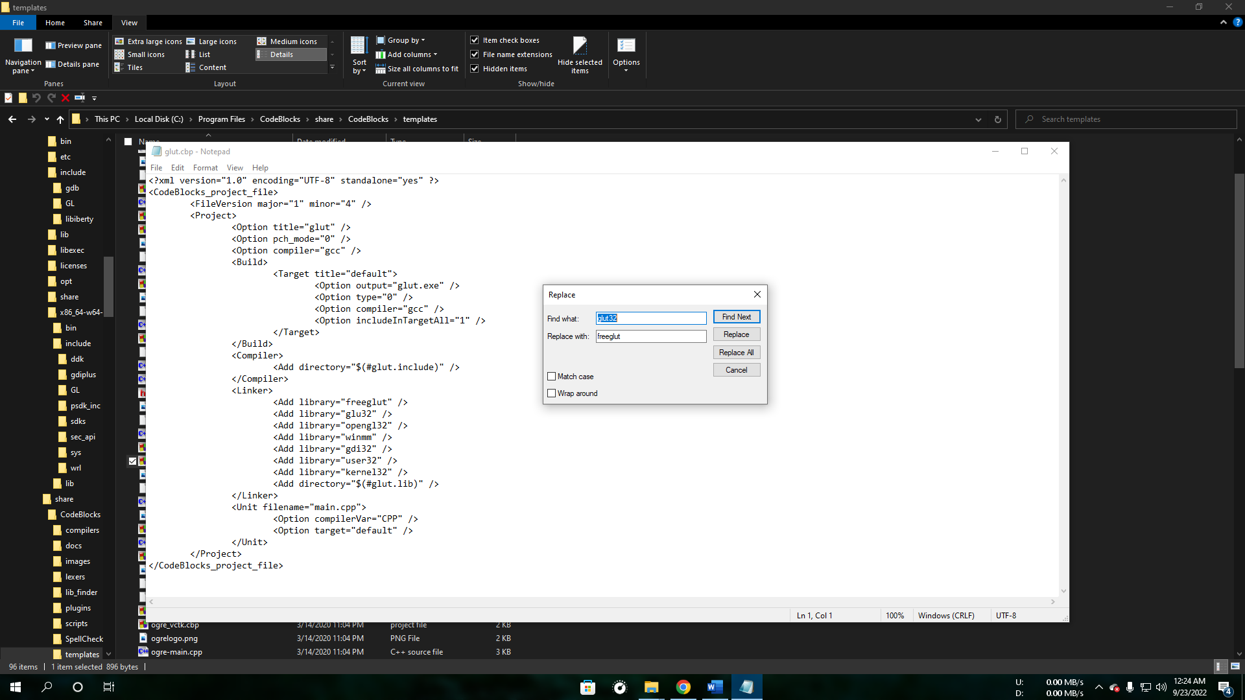

1. Now enter the “wizard” folder > glut then edit “wizard.script” and replace all ‘glut32’ with ‘freeglut’.

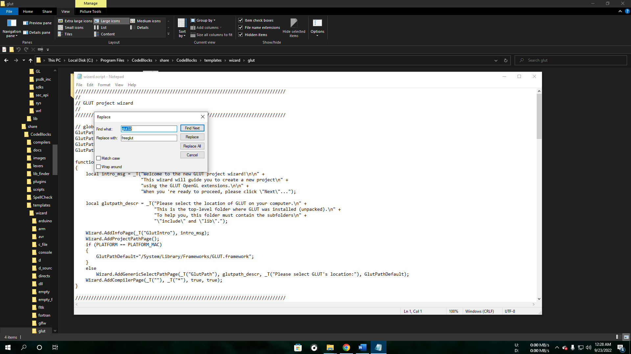

1. Now from <freeglut> enter include > GL copy all file to <CodeBlocks> enter MinGW > x86_64-w64-mingw32 > include > GL

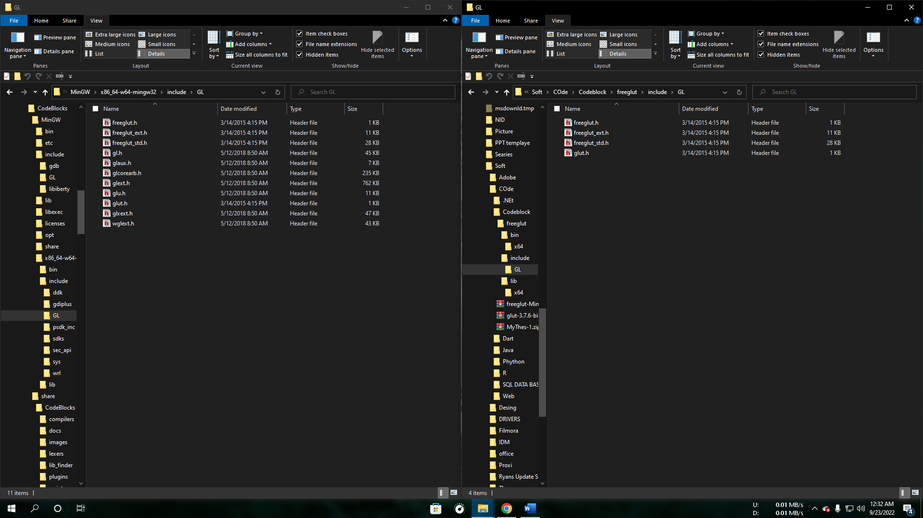

1. Now from <freeglut> enter lib and lib > x64 copy all file to <CodeBlocks> enter MinGW > x86_64-w64-mingw32 > lib

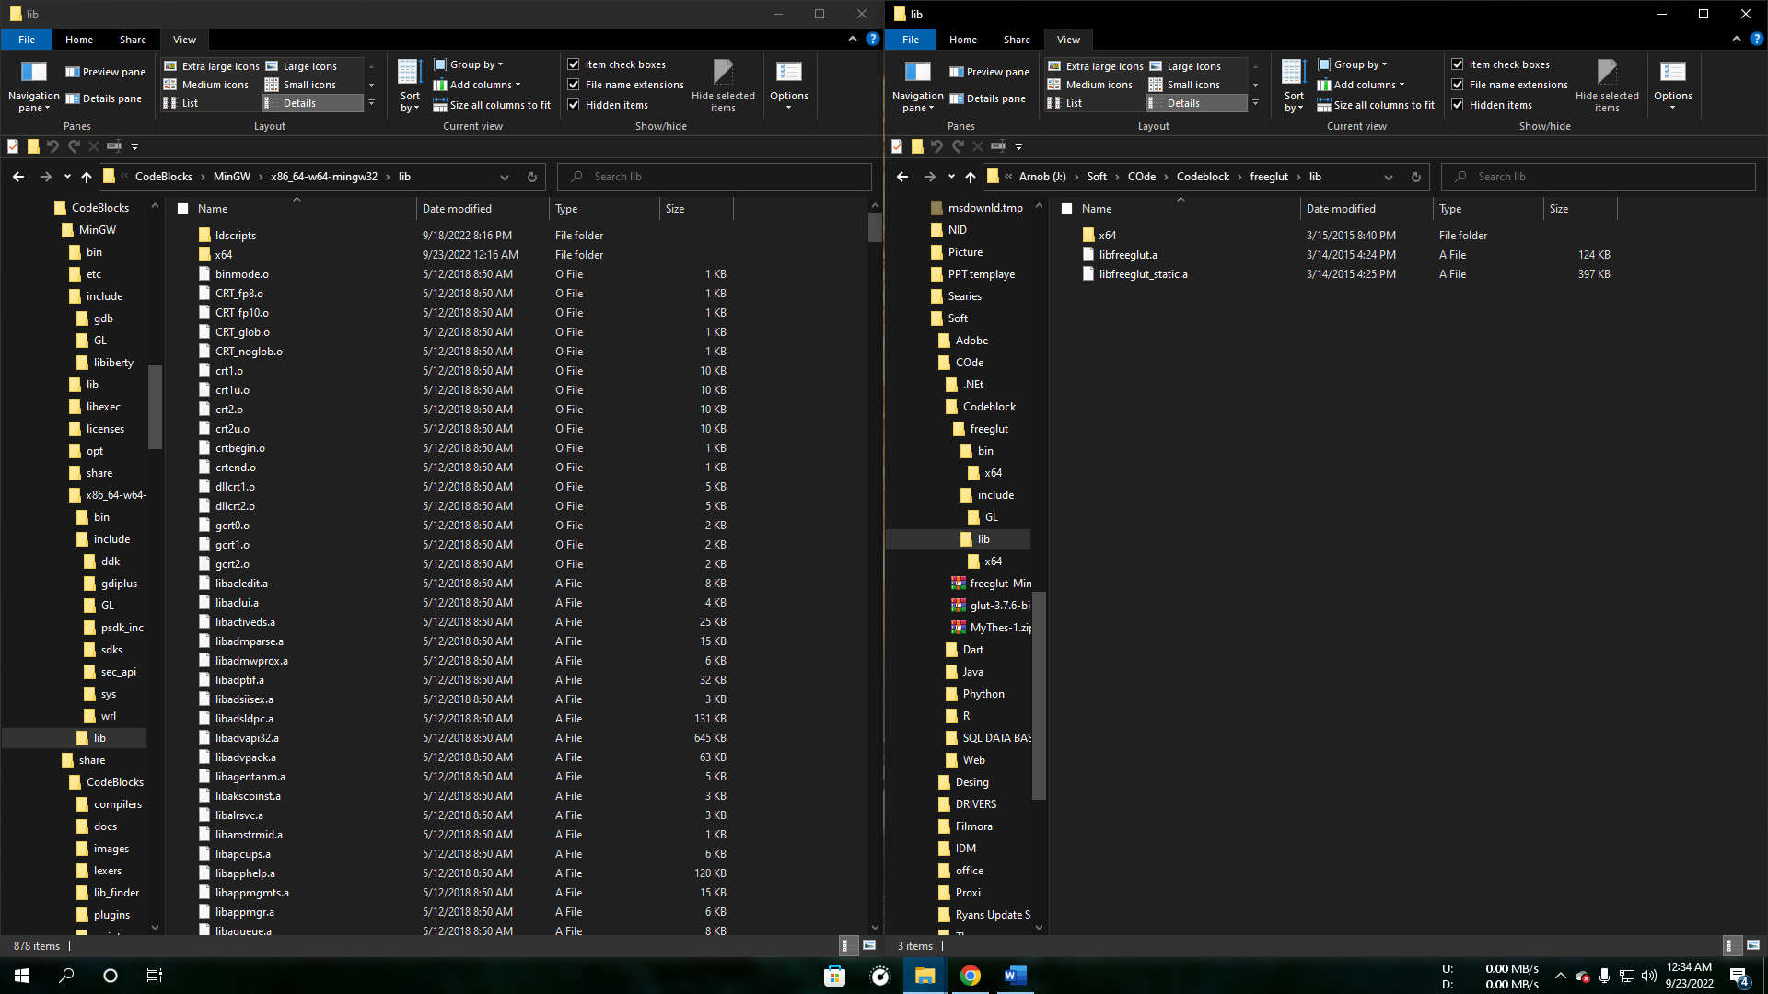

1. Now from <freeglut> enter lib copy all files to C: > Windows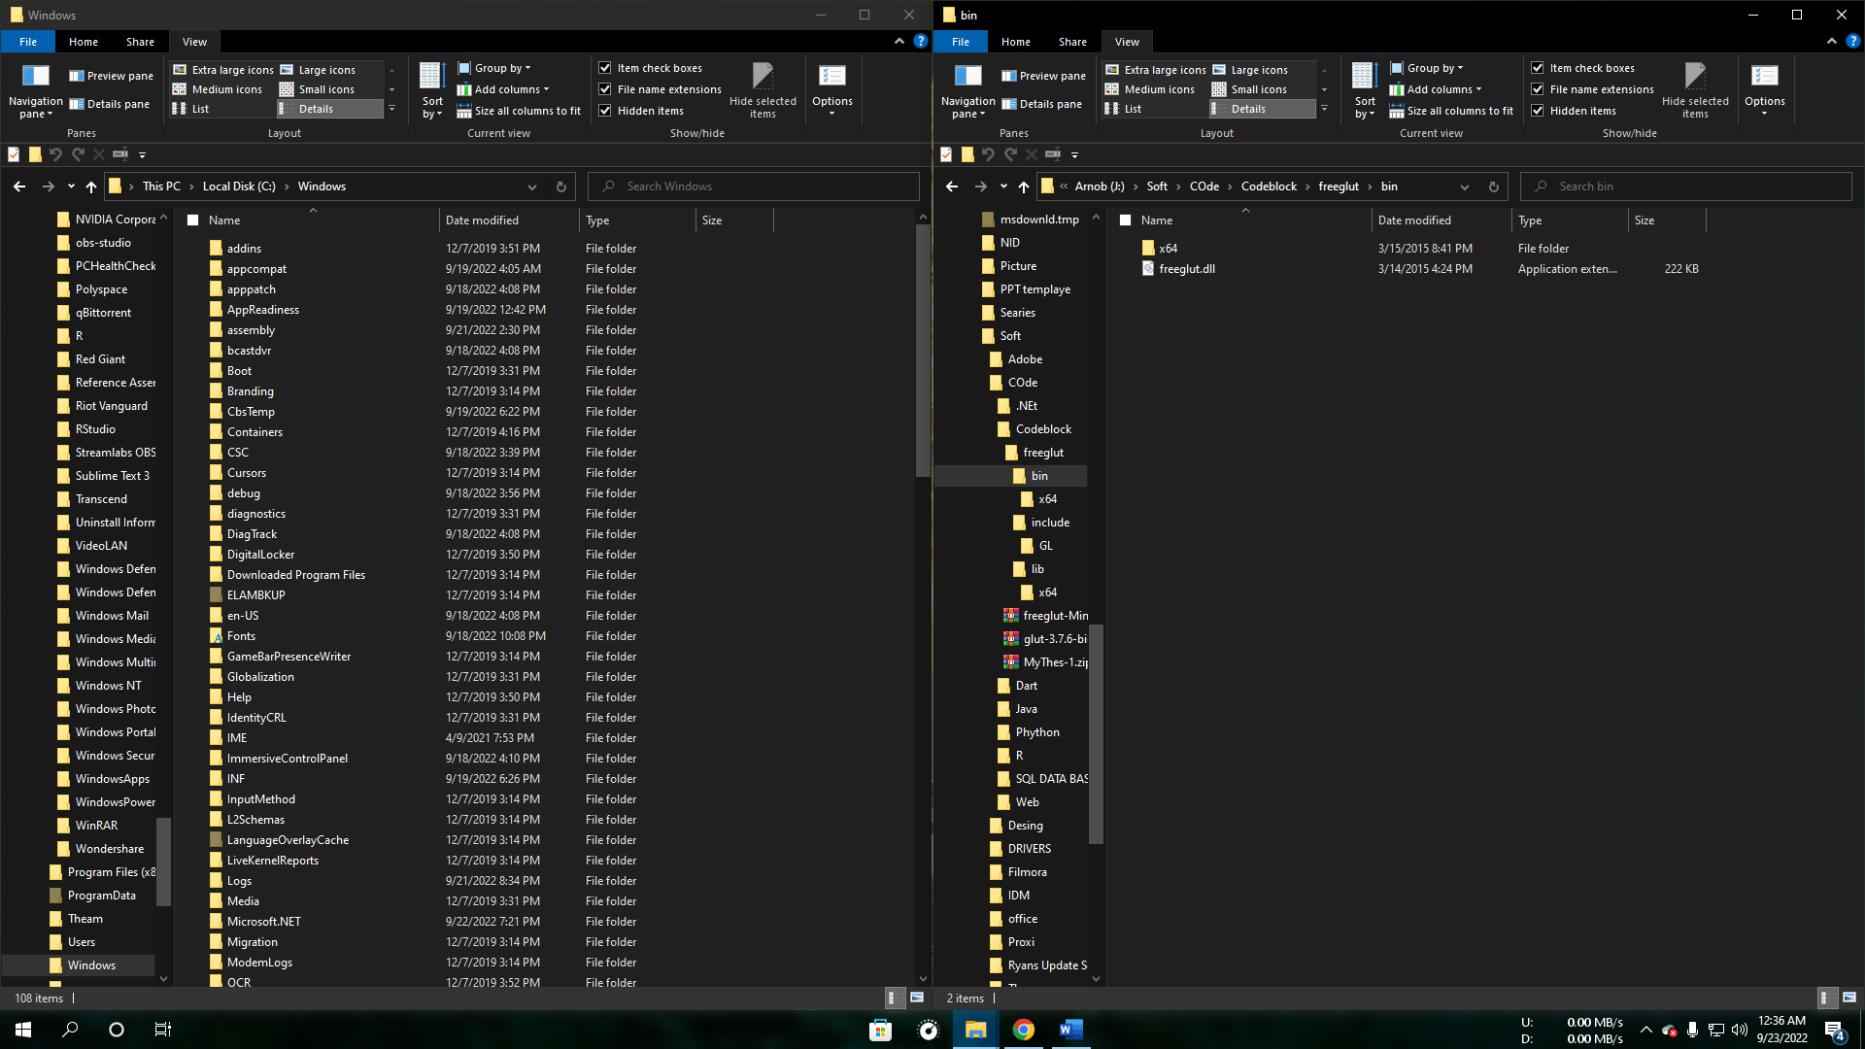
2. 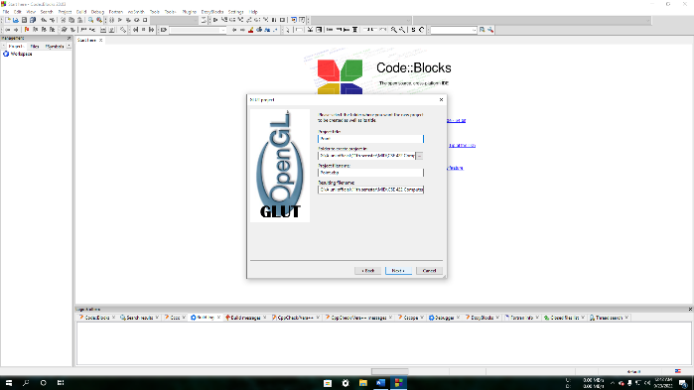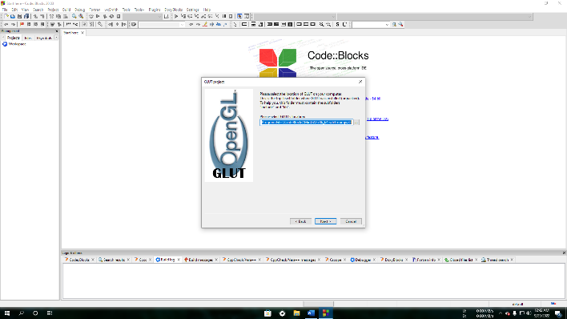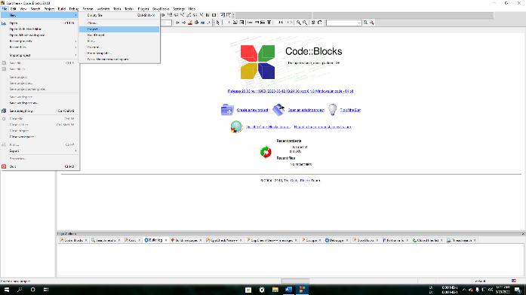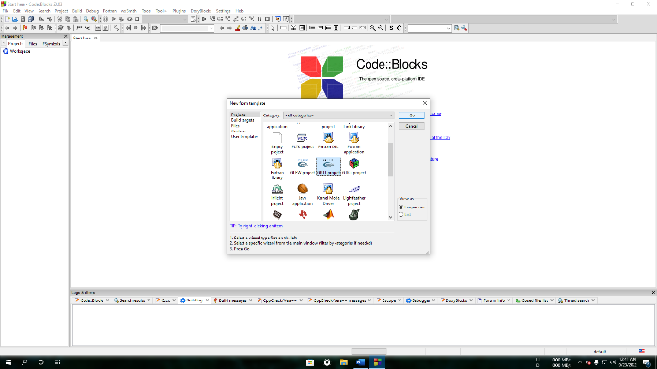Now open “CodeBlocks” and open a project of “OpenGL” and select the compiler path to <CodeBlocks> MinGW > x86_64-w64-mingw32

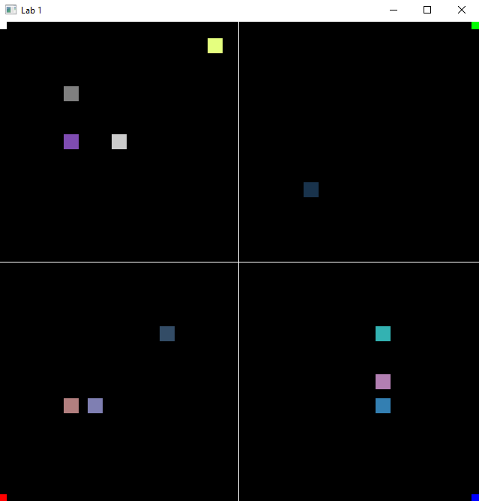Output: